Progression Step 3
(Years 4, 5 and 6)
Information Booklet 2023/24

St. Andrew’s Primary School

Jenkins Street

Newport

NP19 0GR

Headteacher: Mrs J Giles

Telephone: 01633 257261

Email: standrews.primary@newportschools.wales

Twitter: @5tAndrews

Dear Parents / Carers,

We would like to welcome your child to a new year at St. Andrew’s Primary School. We aim to ensure that your child will have a very happy and successful year, and hope that we are able to work together to ensure they reach for the stars and achieve their full potential.

There are a number of things that you need to know at the start of the year. We hope we have included most of them here, but please see your child’s class teacher if there is anything else you are unsure about.

The Progression Step 3 team (Years 4, 5 and 6)
Year 4  4RT – Miss R Tresilian  4LD – Miss L Dyer  4KW – Mrs B Kaur + Miss S Walden | Year 5  5BN – Mrs K Nicholas (Assistant Headteacher + Phase Leader) + Miss C Birkett (SMT)  5AK – Miss A King  5JR – Miss J Richards | Year 6  6PW – Mrs C Palmer + Mrs H Wood (SMT)  6EB – Mrs Brewster  6CG – Miss C Griggs
Radio REACH Lead
Laura Price
EAL support
Miss S Islam
PPA Staff
Miss S Simmonds
Miss K Roach
Support Staff
Mr. D Butler
Miss B Norman
Mrs S Williams
Miss E Richards

Arrival in School

Year group | Arrival time | Collection time | Collection point
Year 4 | 8:50am | 3:25pm | Main grassed astro-turf area
Year 5 | 8.40am | 3:15pm | Main grassed astro-turf area
Year 6 | 8:40am | 3.15pm | Main grassed astro-turf area

Please adhere closely to these times and please leave school gate areas promptly. Pupils in Years 5 and 6 are allowed to leave site and walk home alone as long as parents / carers have provided written permission for this. A permission slip (on Google Forms) for this went home via text message during the summer term. It can be retrieved from class teachers if needed at this current time. Please ensure children do not play on the wooden equipment before and
after school.

Buses
Due to our temporary main site closure, the children in Progression Step 3 will be catching a bus daily back and forth to the new school site. It is imperative that families adhere to these timings and ensure that their child is at our main St. Andrew’s site for the indicated times below to enable a safe and structured start to every school day. We thank you for your support with this.
Year group | Timings | Location
Year 5 + 6 Breakfast Club | 8.00am | KS2 Canteen
Years 5 + 6 | 8.40am  8.45am  3.00pm  3.15pm | Astro turf  Bus – Corporation Road  Leave Connect  Bus arrives | All pupils
Year 4  Breakfast Club | 8.00am | KS2 Canteen
Years 3 + 4 | 8.50am  9.00am  3.10pm  3.25pm | Astro turf  Bus – Corporation Road  Leave Connect  Bus arrives | All pupils

Our Curriculum

At St. Andrew’s, along with other schools across Wales, we are developing the Curriculum for Wales which officially became statutory in September 2022. This curriculum consists of six Areas of Learning and Experiences, Four Purposes and three Cross Curricular Responsibilities.
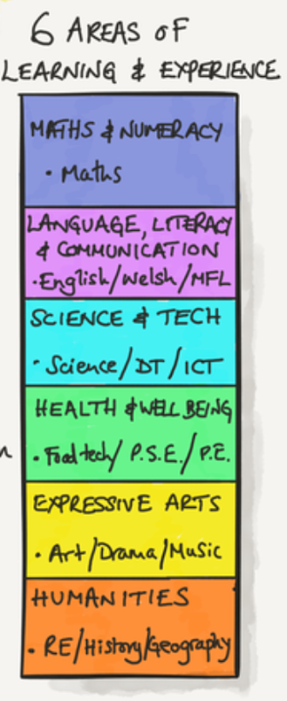

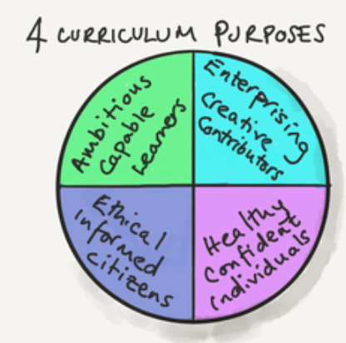
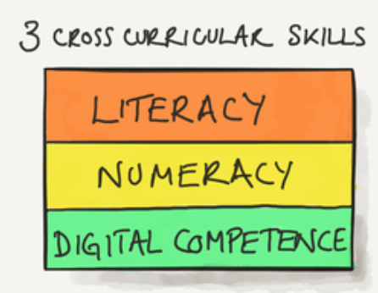

We are lucky enough to be designing our own curriculum around these principles. We are striving to make each learning experience authentic and driven by our learners, as well as other stakeholders within the school, such as yourselves as parents and carers of our community. Through these experiences, we ensure that the Four Purposes are at the heart of our curriculum, whilst being driven by the six Areas of Learning and Experiences and three Cross Curricular Responsibilities. It is a really exciting time for St. Andrew’s and Wales as a whole. We are looking forward to sharing everything our learners achieve this year with you.

Through these experiences, there are basic principles and resources we use that you may find useful:

Languages, Literacy and Communication

Children practise developing their oracy, listening, reading, writing, spelling and handwriting skills across all areas of the curriculum. We feel it is imperative to form letters accurately and emphasise the importance of neat presentation and pride in our work at all times. We appreciate your encouragement of this with your children.

When focusing on handwriting, we use Nelson Handwriting resources starting in Progression Step 1 and progressing throughout Progression Steps 2 and 3 to ensure children can form and join letters confidently and correctly. Each week, children are given a set of words to learn and practise. The majority of the words are linked to a spelling pattern or sound that the children have been learning about in class that week through our Spelling Shed sessions. Children practise these words throughout the course of the week and can be practised at home using the Spelling Shed app / website. These logins will be shared on Seesaw over the next few weeks.

Children are heard reading weekly during Guided Group Reading sessions. This involves an adult listening to a group of children reading an appropriate levelled book. Questioning is an important part of the guided reading session and the children are questioned about the book before, during and after reading. It is vital for children to read regularly outside of school to further improve their confidence and exposure to new texts. Home reading books will be sent home with your child weekly and we appreciate your support in reading with your child at home to support the progress they make in school and develop their enjoyment of reading. Learners also access Giglets in school to support their reading. Children can also access these texts at home using their Giglets account. These logins will be shared on Seesaw over the next few weeks.

We are extremely proud to be Welsh at St. Andrew’s and we ensure that children continue to build upon Welsh language patterns introduced throughout the school. Incidental Welsh is used during the school day and the children are encouraged to use Welsh often, for example, using our Welsh Phrase of the Week which is included in assemblies and our weekly newsletter.

Mathematics and Numeracy

Maths is usually taught in the morning. During Maths lessons, children practise number, problem solving, measures, shape and space and handling data concepts. Mental Maths is given a high priority during interactive warm ups. These warm up sessions include multiplication tables, doubling, halving, number bonds, sequencing etc. The application of these skills is then embedded throughout projects to ensure learners have ample opportunities to apply skills in a variety of contexts. Learners have access to TTRockstars and MyMaths both in school and at home to help practice these vital Maths skills. These logins will be shared on Seesaw over the next few weeks.

Projects

Many of the Areas of Learning and Experiences are taught under the umbrella of ‘projects’ and this allows the children to establish links between the Areas rather than treat them as isolated blocks of study. Children will be given authentic learning experiences across a number of different areas through high quality projects. Regular updates and information regarding projects being covered, upcoming trips etc. will be posted on the school website, our Together Learning website, Twitter (including class Twitter pages) and Seesaw. Check these regularly to stay up to date and follow your child’s Seesaw account and class Twitter page. Setting notifications on Twitter is also a good way of staying up to date with changes. Our Blended Learning Menus are shared fortnightly with our parents / carers through Seesaw and our Together Learning site.

Health and Well-Being
Physical education and outdoor activities play an important part in the development of children. With the current emphasis upon physical and mental well-being, we view it as vital that children are encouraged to take a full and active part in this area of the curriculum. Please support us in ensuring that children’s PE kits are in school for the duration of the week (in on a Monday and home on a Friday if it needs washing) to enable us to partake in these activities throughout the week.

Year 5 pupils will attend swimming lessons this year on a Thursday afternoon. These lessons take place in the Newport International Sports Village.
5JR - Thursday 14th September – Thursday 7th December 2023
5AK - Thursday 14th December 2023 – Thursday 21st March 2024
5BN - Thursday 11th April – Thursday 11th July 2024

Educational Visits

Visits are arranged during the year to enrich the curriculum for the children. Fieldwork and follow up work are important aspects of projects studied in Progression Step 3. Parents will be informed of upcoming trips via letter and parental support is greatly appreciated on these trips.

After School Clubs

We are proud to offer a range of lunch and after-school clubs to learners in Progression Step 3.

Monday | Activity | Location | Staff member(s) | Time | Year groups
 | Netball | MUGA | Miss Lloyd | 3.15 - 4.15pm | Years 3 + 4
 | Dance | Milner Hall | Miss Tresilian | 3.15 - 4.15pm | Years 3 - 6
 | Gardening club | Milner site | Miss Morgan | 3.15 - 4.15pm | Years 3 - 6

Wednesday | Activity | Location | Staff member(s) | Time | Year groups
 | Netball | MUGA | Miss Richards | 3.15 - 4.15pm | Year 5 + 6
 | Football | Milner yard | Mr A Martin / Miss Hurley-Bowditch | 3.15 - 4.15pm | Years 3 + 4
 | Artists Assemble | Classroom 6PW | Mrs Palmer | 1.00 – 1.30pm | Years 5 + 6
 | Spanish | Classroom 5BN | Miss Birkett | 1.00 – 1.30pm | Years 5 - 6
 | Craft Club | Classroom 4KW | Miss Walden and Mrs Kaur | 12.00 – 12.30pm | Years 3 - 4
 | Board games / Chess | Classroom 4LD | Miss Dyer | 12.00 – 12.30pm | Years 3 - 4
 | Board games / Chess | Classroom 5AK | Miss King and Mrs Brewster | 1.00 – 1.30pm | Years 5 - 6
 | KS2 Choir | Connect Hall | Miss Price | Morning slot | Years 3 - 6

Thursday | Activity | Location | Staff member(s) | Time | Year groups
 | Wellbeing | Classroom 3SH | Mrs Hastings | 12.00 – 12.30pm | Years 3 - 4

Learning Leaders

We are proud to offer a range of Learning Leaders teams who support our school.

Learning Leaders | Criw  Cymraeg | Connect Centre | Mrs Wood | During Learner Leader slots – school day | Year 3 - 6
 | School  Council | Milner / Connect | Mrs Charles |  | Year 1 - 6
 | Radio Reach DJs | Connect | Miss Price |  | Year 3 - 6
 | Heddlu Bach | Connect | Mrs Hastings |  | Year 3 - 6
 | Eco-Council | Milner / Connect | Mrs Hatherall / Mrs Brown |  | Year 1 - 6
 | Young  Interpreters | Connect | Mr Martin / Miss Birkett |  | Year 3 - 6
 | Playground Leaders FP | Milner | Miss Glynn |  | Year 1 - 2
 | Playground Leaders KS 2 | Connect | Miss Doherty |  | Year 3 - 6
 | Writing Squad | Connect | Mrs Nicholas |  | Year 5 - 6
 | Super  Ambassadors | Connect | Miss Richards |  | Year 5 - 6
 | Digital  Leaders | Connect | Mrs Nowaczyk |  | Year 3 - 6

School Events

We have a number of exciting events throughout the year which parents are invited to either attend or support such as:

- Class Assemblies
- Christmas Concerts
- Eisteddfod
- Sports Day
- Summer Fete
- Themed weeks – we have a number of themed weeks, such as Anti-Bullying Week and Cultural Diversity Week. These events will be explained further closer to the time via the newsletter.

We are pleased to say that parents and carers can now come to watch our class assemblies again. These will be held at the Connect site for Progression Step 3 learners. Further details about your child’s class assembly will be shared with you by the class teacher closer to the date of their assembly.

Water Bottles / Snacks

Only fruit, vegetables or healthy snack bars are allowed to be eaten as a playtime snack in school. We encourage children to drink water freely at school to stay hydrated. Children have access to drinking water throughout the school day. We ask that children do not bring fizzy/ energy drinks to school. Water bottles can be purchased through the office. Please ask for more details.

Pencil cases are not required at school as we have all the equipment that children will need within school and we wouldn’t want children to lose their personal belongings. Children are only required to bring a bag for PE kit and lunch (if applicable).

PPA

All teachers are required to spend 10% of the school week planning, preparing and assessing children’s work. At St. Andrew’s, we organise this by using an additional member of staff. Supporting us this year are Miss Simmonds and Miss Roach who run exciting Commando Joe sessions, focusing on important team building and outdoor skills during this time.

What should your child do if they have a problem?

- Tell their class teacher or any member of staff
- Tell someone at home

A small problem to an adult can seem enormous to a child but can often be quickly solved. Therefore, it is important that a child tells somebody who can do something about it. Please make sure that your child knows that we are always available to listen and help. There are several options if your child feels uncomfortable about approaching a specific person. Please liaise with your child’s class teacher or Mrs K Nicholas (Assistant Headteacher + Progression Step Leader) if you have any queries.

Our School Rules
- Always try our best at all times.
- Follow instructions first time.
- Listen to the chosen speaker.
- Walk sensibly and quietly around the school.
- Keep hands, feet, objects and unkind words to ourselves.

Gwent Education Minority Ethnic Service (GEMS)
Gwent Education Minority Ethnic Service (GEMS) supports Newport pupils whose first language is not English or Welsh. They work closely with schools and parents to help pupils improve their English language skills. GEMS staff are vital to supporting pupils with transition and their grasping of the English language within our school. Miss Islam and Mrs Williams will be supporting GEMS and our EAL pupils this year.

Social Media

Over the last few years, there have been an increasing number of incidents regarding social media websites. Although it’s at parents’ discretion, we do not condone children’s use of social media sites with age restrictions for under 13, e.g. Facebook, Snapchat, Instagram, etc. The use of Facebook or other social media sites is not permitted in school time or on school equipment. E-Safety is a very important part of our curriculum and children are taught about safety online every year. As a school, we are proud to have our very own YouTube channel, Twitter page and separate class Twitter pages which we use regularly to celebrate amazing moments in school.

Home Learning

In the coming weeks, children will be sent home with login information for the various platforms we use for learning in school which can also be used at home. These platforms are: Spelling Shed, Times Table Rockstars, MyMaths and Giglets. We would really appreciate you encouraging your child to access these educational sites at home to support the progress they are making in school. If you need any support accessing these, please contact your child’s class teacher.

Seesaw

We are continuing to use Seesaw this year to celebrate your child’s learning with you through a safe and secure network. You should have received your QR code login sheet last week. Please follow the instructions to log in so we can start celebrating your child’s learning with you. If you have not received your login sheet, please go to the office or speak to your child’s class teacher who will be happy to help with this.

Twitter

Another platform we use to celebrate learning is Twitter. We use year group Twitter accounts which will allow you to easily find what your child’s class is up to. Please follow our Twitter accounts: @sapsyear4 for Year 5, @saps_y5 for Year 5 and @sapsyear6 for Year 6.

Transition to Secondary School

Throughout the year, there will be a series of activities designed to ensure a smooth transition for your child from St. Andrew’s Primary to their secondary school. This includes a number of
curriculum taster days at Lliswerry High School (our catchment school), undertaking a tour of the school, meeting their new form teachers towards the end of the summer term and visits by High School staff and former pupils to help ease concerns and answer questions. Families of children who are transferring out of catchment will be contacted by the relevant schools.

We hope that you have found this information useful and if you have any questions, please see your child’s class teacher or Mrs Nicholas as Progression Step Lead who will be more than happy to help. We are committed to working with you throughout the year to help your child, and we look forward to forging a successful partnership with you over the course of the year.

Many thanks,

Mrs Nicholas and the Progression Step 3 team

